**Employee Management System**

**Senior Capstone Project Presented to the Faculty of Business Administration**

**Department of Management Information System**

**Al Maaref University**

**In Partial Fulfillment of the**

**Requirements for the Degree**

**Bachelor of Business**

**Management Information System**

**Spring 2023-202**

**Al Maaref University**



**Faculty of Business Administration**

**Approval of the Senior Capstone Project**

**Candidate:** Zahraa Ahmad Neameh

**Degree:** Bachelor of Business in Management Information System

**Title:** Employee Management System

**Advisor: Signature:**

**Dedication:**

I extend my profound gratitude to Prof. Bassam Hamdar, Dean of the Faculty of Business Administration at Al Maaref University, for his invaluable support in facilitating the application of my educational expertise. Dr. Kassem Danash, my senior project supervisor, deserves special acknowledgment for his unwavering dedication and insightful guidance. My gratitude also extends to the faculty members whose knowledge enriched my path. Lastly, heartfelt thanks to my family and friends for their unwavering support and belief in my aspirations. Their collective contributions have been instrumental in the success of this endeavor.

Table of Contents

1 Chapter one: Introduction 7

1.1 General Overview 7

1.2 Research Gap 8

1.3 Research Objectives 8

1.4 Research Questions 9

1.5 Research Hypothesis 9

1.6 Scope 10

1.7 Ethics 10

1.8 Chapter Distribution 12

2 Chapter Two: literature Review 13

2.1 Introduction of the Literature Review 13

2.2 Existing Data Management Approaches in Employee Management System 14

2.3 The Need for Tailored Data Management Solutions 15

2.4 Key Features and Functionalities 16

2.5 Efficiency and Effectiveness 17

2.6 Potential Benefits and Impacts 18

2.7 Challenges and Limitations of Data-Driven in Employee Management System 19

2.8 Popular Views 20

2.9 Conclusion and Future Directions and Developments 21

3 Chapter Three: Methodology 22

3.1 Research Philosophy 22

3.2 Methodology Choice 23

3.3 System Analysis 24

3.4 Need for Fact-Finding Techniques 24

3.5 Category 26

3.6 SDLC Stages 28

3.7 Discussion 30

4 Chapter Four: Analysis and Design 31

4.1 Functional Requirements 31

4.2 Non-functional Requirements 33

4.3 Scenarios 33

4.4 Design 35

5 Chapter Five: System Architecture 35

5.1 Database 35

5.2 Register Form 36

5.3 Log-in Page 37

5.4 Main Form 37

5.5 Dashboard 38

5.6 Add Employees 39

5.7 Employee’s Salary 40

6 Chapter Six: Conclusion and Recommendations 41

6.1 Conclusion 41

6.2 Limitations of the Study 42

6.3 Recommendations 43

6.4 References 44

**Abstract:**

This research endeavors to design and implement an advanced employee management system, comprising six fundamental forms tailored to streamline organizational operations. Each chapter within this study meticulously dissects various facets of system development, offering a comprehensive roadmap from research inception to practical implementation. The literature review navigates through existing data management approaches in employee management systems, accentuating the necessity for bespoke solutions to enhance operational efficiency and effectiveness. Methodological considerations encompass critical elements such as research philosophy, system analysis methodologies, and the Software Development Life Cycle (SDLC), providing a robust foundation for systematic system design and evaluation.

Furthermore, the analysis and design chapter meticulously delineates both functional and non-functional requirements, along with detailed scenarios and architectural design considerations, ensuring a holistic understanding of system functionalities and user interface design principles. Through a deep dive into system architecture, including database structures and key interface designs, this study lays bare the technical backbone of the proposed employee management system. Finally, the conclusion and recommendations chapter synthesizes research insights, acknowledges inherent limitations, and propounds actionable recommendations for system refinement and future research avenues, underscoring a commitment to continuous improvement and innovation in employee management practices.

Keywords: Employee management system, system architecture, data management, software development life cycle, user interface design, system analysis, functional requirements, non-functional requirements, research methodology, recommendation.

# Chapter one: Introduction

## General Overview

Employee management is the cornerstone of organizational efficiency, demanding seamless coordination and effective utilization of human resources. However, the presence of disparate data and complex workflows often hinders streamlined operations, leading to inefficiencies and potential errors. In response, an advanced Employee Management System emerges as a pivotal solution, transcending conventional approaches to become an indispensable tool for optimizing workforce productivity.

This Employee Management System revolutionizes traditional practices, automating routine tasks and empowering managers to focus on strategic decision-making and personnel development. Through intuitive interfaces and comprehensive documentation, the system elevates employee management beyond cumbersome paperwork, significantly reducing administrative overhead and enhancing organizational agility.

Central to its functionality is the seamless flow of data, providing decision-makers with real-time insights into workforce dynamics, performance metrics, and talent development opportunities. Robust access controls ensure data security while empowering individual users, simplifying user management and fostering a culture of accountability.

Addressing core challenges within employee management, this system significantly streamlines workflows, reducing processing times and allowing managers to prioritize strategic initiatives. By harnessing the power of data analytics, it facilitates informed decision-making and amplifies operational efficiency. Furthermore, it fosters trust among stakeholders by safeguarding critical employee data through role-based access controls.

More than just a software solution, this Employee Management System serves as a catalyst for transformative change within organizational structures. Its benefits include heightened operational efficiency, improved talent management through data-driven insights, and substantial cost savings through optimized resource allocation. As organizations embrace this innovative solution, they unlock new avenues for growth and advancement in the realm of employee management.

## Research Gap

In the realm of employee management, organizations often grapple with fragmented data, manual processes, and limited analytics, hindering efficiency, decision-making, and workforce optimization.

Existing systems primarily cater to large-scale enterprises, offering extensive analytics capabilities but requiring substantial infrastructure and expertise, making them inaccessible to smaller organizations.

There exists a clear need for tailored data management solutions that empower individual businesses to harness data effectively without imposing overwhelming resource requirements or technical barriers.

An innovative approach to address this gap involves the implementation of a centralized, secure data platform within the Employee Management System. This platform seamlessly integrates data from various sources, automates data entry and cleaning processes to reduce errors and save time, and offers intuitive data visualization and analytics features tailored to the specific needs of each organization.

By bridging this gap, the Employee Management System empowers businesses of all sizes to unlock the full potential of their workforce by harnessing data-driven insights and optimizing decision-making processes.

## Research Objectives

1. Evaluate the effectiveness of the Employee Management System's data integration and automation features in reducing manual tasks and errors, while also assessing the time saved for administrative staff.
2. Assess the usability and intuitiveness of the Employee Management System's data visualization and analytics tools for non-technical personnel, and evaluate their impact on facilitating informed decision-making within the organization.
3. Investigate the influence of the Employee Management System's data-driven insights on employee outcomes, including job satisfaction, productivity, and overall engagement.
4. Measure the cost-effectiveness of implementing and maintaining the Employee Management System compared to traditional methods of data management within the organization.
5. Analyze user feedback on the Employee Management System interface, features, and security measures to identify areas for enhancement and ensure alignment with user requirements and preferences.

## Research Questions

1. To what extent can a customized data management solution increase productivity, facilitate decision-making, and improve employee care in individual organizations while addressing resource restrictions and technological barriers?
2. How effectively does the Employee Management System integrate and automate data processes compared to previous approaches?
3. Is the cost of establishing and maintaining the Employee Management System in individual organizations equivalent to or less expensive than standard data management methods?
4. How user-friendly are the data visualization and analytics capabilities of the Employee Management System for non-technical staff members to use, considering the simplicity of navigation and comprehensibility of presented data?

## Research Hypothesis

Implementation of the Employee Management System, encompassing features such as employee registration, data entry, salary management, training tracking, dashboard analytics, and a user-friendly survey interface, will lead to a substantial enhancement in organizational efficiency. This enhancement will be demonstrated by the reduction of manual administrative tasks, streamlined data management processes, improved decision-making capabilities, increased employee engagement through survey participation, and ultimately, elevated levels of employee satisfaction and organizational performance.

## Scope

The proposed project entails the design, development, and implementation of a sophisticated Employee Management System, encompassing essential functionalities such as login, registration, employee data entry, salary management, training tracking, dashboard analytics, and a user-friendly survey interface. Emphasizing user-centric design principles, the system aims to enhance accessibility and usability for non-technical staff members, while robust security measures ensure the protection of sensitive employee information. Integration of data storage mechanisms facilitates efficient management and retrieval of employee data, supported by advanced data visualization and analytics tools within the dashboard interface. Through iterative improvements and usability testing, the project seeks to optimize the system's interface and navigation for seamless user experience. Evaluation metrics will assess the system's impact on organizational efficiency, productivity, and employee satisfaction, with a focus on quantifiable metrics and cost-effectiveness compared to traditional data management methods. Continuous monitoring and feedback-driven enhancements ensure ongoing alignment with organizational needs and industry best practices.

## Ethics

In the context of developing an Employee Management System, several ethical considerations arise:

1. **Data Privacy and Security**: Ensuring that employee data is collected, stored, and used in compliance with relevant data protection laws and regulations (e.g., GDPR, HIPAA). Implementing robust security measures to safeguard sensitive information from unauthorized access, breaches, or misuse.
2. **Transparency and Consent**: Obtaining informed consent from employees for the collection and processing of their personal data. Providing clear and transparent information about how their data will be used, who will have access to it, and their rights regarding data access, rectification, and deletion.
3. **Fairness and Non-discrimination**: Ensuring that the Employee Management System does not facilitate or perpetuate unfair or discriminatory practices in recruitment, promotion, salary allocation, or performance evaluation. Implementing safeguards to prevent biases in algorithmic decision-making processes.
4. **Accuracy and Integrity of Data**: Striving to maintain the accuracy and integrity of employee data stored within the system, by regularly updating records, conducting data validation checks, and providing mechanisms for employees to review and correct their information.
5. **Access Control and User Permissions**: Implementing granular access controls and user permissions to restrict access to sensitive employee data only to authorized personnel who have a legitimate need to know. Preventing unauthorized access or misuse of data through appropriate authentication mechanisms.
6. **Accountability and Governance**: Establishing clear accountability frameworks and governance structures to oversee the responsible use of the Employee Management System. Designating individuals or teams responsible for data protection, compliance, and ethical oversight.
7. **Ethical Use of Analytics**: Ensuring that data analytics and insights derived from the system are used ethically and responsibly, avoiding misuse or misinterpretation of data to make biased or discriminatory decisions. Providing training and guidance to users on the ethical use of analytics for decision-making.
8. **Continuous Monitoring and Improvement**: Regularly monitoring the system's performance, data handling practices, and user interactions to identify and address any ethical concerns or compliance issues that may arise. Continuously improving system features and processes to uphold ethical standards and meet evolving regulatory requirements.

By adhering to these ethical principles, developers and users of the Employee Management System can promote trust, integrity, and fairness in the handling of employee data and ensure that the system contributes positively to organizational objectives while respecting individual rights and dignity.

## Chapter Distribution

1. **Chapter 1: Introduction**: This chapter provides an overarching introduction to the research, delineating the significance of employee management systems and identifying the research gap. It outlines the specific objectives, questions, and hypotheses that guide the study, while also establishing the scope and ethical considerations. Additionally, it offers a brief overview of how the subsequent chapters are organized to address the research objectives comprehensively.
2. **Chapter 2: Literature Review**: In this chapter, an in-depth review of existing literature on employee management systems is presented. It begins with an introduction to the importance of data management approaches in such systems, followed by an examination of various methodologies and their effectiveness. Key features, functionalities, benefits, and challenges associated with data-driven systems are explored, along with popular views in the field. Finally, the chapter concludes with insights into future directions and developments.
3. **Chapter 3: Methodology**: The methodology chapter outlines the research philosophy and justifies the choice of methodology employed in the study. It describes the systematic approach to system analysis, emphasizing the need for fact-finding techniques to gather relevant data. Additionally, it elucidates the different stages of the Software Development Life Cycle (SDLC) adopted for the research, providing a robust framework for subsequent chapters.
4. **Chapter 4: Analysis and Design**: This chapter delves into the functional and non-functional requirements of the employee management system. It presents various scenarios to analyze system functionalities and designs solutions accordingly. The chapter also discusses the architectural design of the system, highlighting the database structure and key interface designs, such as the login page and main form, with a focus on usability and efficiency.
5. **Chapter 5: System Architecture**: Here, the focus is on the technical architecture of the employee management system. The database structure is detailed, elucidating its role as the core store for application data. Additionally, specific forms within the system, including the register form, login page, dashboard, add employees form, and salary form, are examined in terms of their design, functionality, and integration within the system.
6. **Chapter 6: Conclusion and Recommendations**: The final chapter provides a comprehensive conclusion to the research findings and offers recommendations for future studies. It summarizes the key insights gleaned from the study, acknowledges any limitations encountered, and proposes recommendations for further research or system enhancements. Additionally, it includes a list of references for further reading and academic integrity.

# Chapter Two: literature Review

## Introduction of the Literature Review

In the realm of employee management, organizations often grapple with challenges related to ineffective data management stemming from manual procedures, disjointed systems, and limited analytical resources. These constraints can result in costly errors, impede informed decision-making, and ultimately impact employee satisfaction and organizational performance (Smith et al., 2018; Jones & Patel, 2021). However, the development of customized data management systems presents a promising solution to address these challenges and empower organizations with enhanced capabilities. These solutions offer seamless data integration and automation, eliminating manual data entry and optimizing workflows to improve efficiency and accuracy (Brown et al., 2019; Johnson & Wang, 2020). Additionally, the implementation of data visualization and analytics tools simplifies the interpretation of complex data sets, enabling informed decision-making across various organizational functions such as human resource management and performance evaluation (Chen et al., 2022; Miller & Davis, 2023).

This literature review aims to explore the current state of employee data management, identify limitations of traditional approaches, and assess the potential of personalized data management solutions, with a specific focus on the Employee Management System developed for this project. We will examine existing research on data management inefficiencies and constraints in organizational settings, analyzing their impact on operational efficiency, decision-making processes, and employee satisfaction. Subsequently, we will evaluate the capabilities of the Employee Management System, including data integration, automation, and visualization features, to address these challenges and enhance organizational performance. Furthermore, we will explore the potential benefits of utilizing the Employee Management System, such as increased efficiency, data-driven decision-making, and cost savings, drawing insights from relevant research and real-world examples. Finally, we will discuss potential challenges and limitations associated with data-driven systems in employee management, including ethical considerations and user acceptance barriers.

Through this comprehensive assessment, we aim to demonstrate the potential of the Employee Management System as a valuable tool for increasing organizational efficiency, optimizing decision-making processes, and ultimately improving the bottom line for organizations. By harnessing the power of data, organizations can navigate a competitive landscape, optimize resource allocation, and prioritize employee well-being, thus fostering a conducive work environment and enhancing overall organizational success.

## Existing Data Management Approaches in Employee Management System

Employee management systems, pivotal for organizational operations, often grapple with inefficient data administration, characterized by fragmented systems and labor-intensive manual processes. This section scrutinizes the limitations of prevailing data management approaches in employee management systems, evaluating their efficacy, drawbacks, and impact on operational efficiency, data-driven decision-making, and employee satisfaction.

The inefficiencies in current systems stem from a reliance on fragmented platforms, resulting in disconnected databases and data silos. This fragmentation impedes data accessibility, complicates comprehensive analysis, and heightens the risk of errors and discrepancies. Additionally, manual data entry exacerbates these challenges, introducing inefficiencies, transcription errors, and delays in accessing vital information. Beyond consuming valuable staff time, manual data entry compromises data accuracy and reliability.

While conventional systems may offer basic reporting capabilities, they often lack sophisticated analytics tools, hindering the identification of trends, optimization of resources, and strategic decision-making. Consequently, pharmacies struggle to leverage data for informed action, leading to reduced operational efficiency and longer wait times for employees accessing critical information.

Moreover, the absence of insightful data hampers data-driven decision-making, particularly in areas like resource allocation and performance management. This deficiency can result in inefficiencies, cost overruns, and missed opportunities for optimization. Despite not directly impacting employee care, the ramifications of these limitations are significant, potentially affecting employee satisfaction and organizational productivity.

While primarily targeting efficiency and data accuracy, the Employee Management System indirectly contributes to enhanced organizational performance and employee satisfaction. By streamlining data management processes, enhancing accessibility, and facilitating informed decision-making, the system lays the foundation for improved operational efficiency and employee well-being.

## The Need for Tailored Data Management Solutions

The current landscape of employee management systems is plagued by inefficiencies stemming from conventional data management approaches. These systems, characterized by disjointed software silos and manual processes, pose significant challenges to organizational effectiveness and employee satisfaction. Employees are burdened with manual data entry tasks, from employee details to salary management, consuming valuable time and risking data accuracy. Moreover, the lack of insightful data hampers data-driven decision-making processes, hindering optimization of resources and strategic growth opportunities. Beyond financial implications, these inefficiencies can compromise employee satisfaction and organizational productivity.

In this environment, tailored data management systems are not just desirable; they are imperative. These systems serve as bridges, addressing inefficiencies and empowering organizations to streamline workflows, automate routine tasks, and focus on employee care. By consolidating data from various sources into a cohesive platform, these systems enable thorough analysis and uncover hidden trends in employee utilization, training effectiveness, and organizational behavior. Moreover, they indirectly contribute to better employee care by reducing data errors and delays, potentially improving employee satisfaction and organizational outcomes.

In summary, the implementation of tailored data management solutions within employee management systems is crucial for enhancing organizational efficiency, optimizing decision-making processes, and ultimately improving employee satisfaction and organizational performance. By leveraging the power of data, organizations can navigate a competitive landscape, maximize resource allocation, and prioritize employee well-being, thus fostering a conducive work environment and enhancing overall organizational success.

## Key Features and Functionalities

In response to the inefficiencies inherent in traditional data management systems, tailored solutions emerge as transformative tools, addressing the unique challenges faced by organizations in managing employee data. These systems boast a range of features and functionalities specifically designed to enhance operational efficiency and empower organizations to make data-driven decisions. Key features include:

1. **Data Consolidation and Integration**: Customized solutions consolidate data from multiple sources, such as employee databases, training records, and performance evaluations, into a centralized platform. This eliminates the need for manual data entry, improves accessibility, and facilitates comprehensive analysis.
2. **Workflow Automation and Streamlining**: Routine tasks, including employee onboarding, performance evaluations, and salary management, are automated, freeing up valuable staff time for strategic initiatives and employee engagement.
3. **Real-Time Data Visualization and Actionable Insights**: User-friendly dashboards and visualizations transform raw data into actionable insights, allowing managers to track employee performance, identify training needs, and make informed decisions to optimize workforce productivity.
4. **Training and Development Management**: These systems facilitate the planning, scheduling, and tracking of employee training programs, ensuring compliance with regulatory requirements and promoting continuous professional development.
5. **Employee Engagement and Satisfaction Monitoring**: Surveys and feedback mechanisms allow organizations to gauge employee satisfaction, identify areas for improvement, and foster a positive work environment.
6. **Enhanced Security and Data Privacy**: Robust security measures, including encryption and access controls, safeguard employee data from unauthorized access or breaches, ensuring compliance with data protection regulations.

Overall, these key features and functionalities enable organizations to streamline employee management processes, improve decision-making, and enhance employee engagement and satisfaction, ultimately contributing to organizational success and competitiveness.

## Efficiency and Effectiveness

The transformative potential of tailored data management systems within employee management systems is profound, evidenced by concrete gains across critical domains. Through automated data integration, these systems replace error-prone manual processes, significantly enhancing accuracy and affording employees more time to focus on their core responsibilities. Real-time data insights enable efficient management of various aspects such as employee records, scheduling, and performance tracking, leading to improved operational efficiency and productivity. Informed decision-making, supported by comprehensive data analysis, facilitates better resource allocation and strategic planning, ultimately contributing to cost savings and organizational growth. Moreover, these systems directly contribute to enhanced employee satisfaction by minimizing administrative burdens and facilitating transparent communication between management and staff. Lower administrative overheads and improved workflow processes further enhance organizational agility and responsiveness to changing business needs. In summary, tailored data management systems serve as catalysts for organizational transformation, driving optimized efficiency, enhanced productivity, and superior employee satisfaction. As essential investments for modern businesses, these systems empower organizations to thrive and maintain a competitive edge in today's dynamic workplace environment.

## Potential Benefits and Impacts

Tailored data management systems for employee management hold immense potential to revolutionize organizational operations and drive value. These advanced technologies bring forth a multitude of benefits that extend beyond individual organizations, impacting the broader landscape of the corporate sector. By automating data entry processes, these systems mitigate the risk of errors, ensuring the integrity of organizational data and empowering informed decision-making. Automation and real-time analytics alleviate employees from mundane administrative tasks, enabling them to allocate more time towards strategic initiatives, employee development, and fostering a positive organizational culture. Real-time data insights facilitate optimized resource allocation, minimizing costs associated with underutilized resources and enhancing operational efficiency.

Financial benefits are abundant, as streamlined workflows and reduced errors lead to significant cost savings across various facets of organizational operations. Organizations can leverage data-driven insights to analyze employee behavior and competitive salary structures, resulting in tailored compensation strategies that drive employee satisfaction and retention. This potent combination of increased efficiency, reduced costs, and data-driven decision-making confers a substantial competitive advantage to organizations within the dynamic corporate landscape.

With reliable data and optimized workflows, employee satisfaction and organizational performance take precedence, reducing the likelihood of administrative errors and fostering a conducive work environment. Proactive engagement, supported by insights into employee behavior, empowers organizations to identify and address issues such as employee turnover and performance gaps, potentially leading to improved organizational outcomes. Streamlining processes, reducing wait times, and enhancing employee accessibility for consultations all contribute to greater employee satisfaction and loyalty, strengthening the bond between the organization and its workforce.

The impact of these systems extends beyond individual organizations, influencing the broader corporate landscape. Improved organizational outcomes are a natural outcome of increased employee satisfaction and decreased administrative errors. Increased data availability and accessibility fuel data-driven decisions across the organizational spectrum, paving the way for more efficient and effective workforce management systems. Finally, these systems empower organizations to equip employees with the knowledge and resources they need to thrive, potentially reshaping the future of corporate culture and workforce dynamics.

In conclusion, the potential benefits and impact of specialized data management systems for employee management are extensive and far-reaching. These innovative solutions hold the key to unlocking a brighter future for organizations, from enhanced operational efficiency and financial benefits to improved employee satisfaction, organizational outcomes, and a transformed corporate workforce. It is through the implementation of advanced data management systems like our employee management system that organizations can realize these benefits and thrive in today's competitive business landscape.

## Challenges and Limitations of Data-Driven in Employee Management System

Incorporating data-driven solutions into employee management systems presents multifaceted challenges and limitations that demand meticulous attention. Foremost among these considerations is the imperative to ensure the integrity and comprehensiveness of data, guarding against inaccuracies that could compromise decision-making processes. Furthermore, the integration of disparate data sources across diverse employee management platforms requires a nuanced approach, necessitating both technical adeptness and seamless interoperability between systems to ensure smooth data flow.

Preserving the confidentiality and security of sensitive employee information emerges as a paramount concern, compelling the implementation of robust security protocols such as advanced encryption mechanisms and stringent access controls to uphold privacy standards. Moreover, the effective utilization of data necessitates a concerted effort to cultivate a culture of data literacy within organizational frameworks, ensuring that insights gleaned are translated into actionable strategies that drive meaningful outcomes.

Additionally, the financial implications of deploying and maintaining these sophisticated systems cannot be underestimated, particularly for smaller entities with limited resources. Despite these formidable challenges, ongoing innovation and strategic implementation strategies remain indispensable in surmounting these barriers and realizing the full potential of data-driven methodologies for optimizing employee management practices.

## Popular Views

The potential of data-driven systems in employee management ignites a spectrum of opinions, from optimism to caution to skepticism.

Forbes (Aug 2023) envisions workplaces transformed into data-driven hubs, armed with insights to optimize employee engagement, tailor training programs, and reduce operational costs. Deloitte (2021) portrays organizations as key players in a data-driven workforce evolution, empowering personalized talent development, targeted employee involvement, and efficient HR processes. McKinsey & Company (Jan 2022) further amplifies this vision, forecasting data-driven workplaces evolving into talent hubs, offering proactive support, skill enhancement, and personalized career paths.

However, pragmatism tempers these aspirations. The Harvard Business Review (Jan 2023) acknowledges the potential for efficiency gains and enhanced productivity but cautions against overlooking data privacy concerns, integration complexities, and the necessity for ongoing skill development. Similarly, HR Magazine (Feb 2023) applauds data analytics for optimizing processes but warns against neglecting the human aspect of employee management, emphasizing the importance of maintaining meaningful employee interactions and preserving the human touch. The New York Times (Aug 2022) adds to the discourse, advocating for transparency in data governance frameworks and highlighting ongoing ethical dilemmas surrounding the use of employee data in organizations.

Skepticism casts a shadow. Industry associations express concern about potential data monopolies favoring large corporations with greater resources. Additionally, concerns arise about opaque practices of data monetization, raising alarms about unauthorized sale of employee data and calling for stricter privacy regulations. The Verge (November 2022) sheds light on these concerns, denouncing the possibility of selling employee data without consent and advocating for stronger privacy legislation. Medscape (Oct 2022) underscores these anxieties, cautioning against the prospect of employee profiling and algorithmic bias influencing data-driven HR decisions.

This diverse range of viewpoints underscores the complexity of this technological transition. Moving forward requires open dialogue, responsible implementation strategies, and unwavering dedication to ensuring that data-driven advancements genuinely serve the interests of employees, organizations, and society as a whole. Only through collaborative efforts can the transformative potential of data-driven systems in employee management be fully realized, illuminating a path towards a more efficient, equitable, and sustainable future for all.

## Conclusion and Future Directions and Developments

As data-driven technologies continue to shape the landscape of employee management systems, it becomes imperative to approach their adoption with careful consideration of ethical principles and responsible practices. Prioritizing robust data security and privacy measures, including encryption, access controls, and transparent governance processes, is paramount to safeguarding sensitive employee information and fostering trust within organizations (Smith et al., 2022, as cited in HR Magazine). Equally essential is the investment in upskilling employees in data literacy and fostering a culture of data-driven decision-making, ensuring effective utilization of these tools to drive organizational success (HR Magazine, 2023). Addressing concerns surrounding data monetization, employee profiling, and algorithmic bias requires proactive engagement and the establishment of clear ethical guidelines to ensure fair and equitable outcomes from technological advancements. Collaborative efforts among technology providers, organizations, regulatory bodies, and industry stakeholders will be instrumental in shaping a future where data-driven systems empower employees, optimize organizational performance, and contribute to a more inclusive and equitable workplace environment for all.

Looking ahead, the evolution of employee management systems will likely see further integration of advanced analytics, machine learning, and artificial intelligence to enhance decision-making processes and streamline HR operations (Gartner, 2023). Additionally, there will be a growing emphasis on user-centric design principles to ensure that these systems are intuitive, accessible, and user-friendly for employees of all skill levels (UX Collective, 2023). Furthermore, the rise of remote work and distributed teams may necessitate the development of specialized features and functionalities to support virtual collaboration, communication, and performance management (Harvard Business Review, 2023). As technology continues to evolve, organizations must remain agile and adaptable, embracing innovation while prioritizing the ethical and human-centered use of data-driven systems to drive positive outcomes for employees and organizations alike.

# Chapter Three: Methodology

## Research Philosophy

To navigate the ethical landscape of data utilization in employee management systems, it is imperative to adopt a research philosophy that balances objective analysis with human experience. This study embraces a pragmatic realist perspective, acknowledging the inherent objectivity of data while also recognizing the subjective interpretations contributed by human actors (Charmaz & Bryant, 2014). This perspective allows for an exploration of the transformative potential of data-driven systems in employee management, while remaining attuned to the diverse interpretations and experiences of employees, managers, and other stakeholders (Dey, 2007). By embracing the contextual nature of data and its significance, this approach aims to illuminate how various actors within the organizational ecosystem interact with information and make decisions within their unique contexts (Bowker & Star, 1999).

Furthermore, this research philosophy underscores an ethical imperative for responsible data collection and usage throughout the research process. All research activities and outcomes are guided by a commitment to benefiting individuals and communities while mitigating potential harms, including biases, privacy concerns, and security risks (Floridi, 2019). While alternative research philosophies, such as positivism and interpretivism[1], offer valuable perspectives, the pragmatic realist approach allows for a nuanced balance between objectivity and subjectivity, empirical evidence, and lived experiences. Ultimately, through ethically grounded inquiry, this research seeks to elucidate the multifaceted implications of data-driven systems in employee management, fostering a future where technological innovations serve the best interests of all stakeholders within the organizational setting.

## Methodology Choice

Unraveling the intricate impact of data-driven systems in employee management necessitates a methodological approach that combines quantitative rigor with qualitative depth. Therefore, this study adopts a mixed methods approach, recognizing the complementary strengths of numerical analysis and narrative exploration in understanding the multifaceted dynamics of organizational data utilization (Creswell & Creswell, 2018).

The quantitative aspect of the study will delve into empirical data generated by the employee management system, employing robust statistical analysis to examine factors such as employee engagement, training effectiveness, and organizational performance metrics (Kitchin, 2014). Additionally, quantitative surveys will capture the perspectives of various stakeholders, including employees, managers, and HR professionals, shedding light on their perceptions and attitudes towards data-driven practices in employee management (Schaeffer, 2012).

However, numerical data alone may not capture the nuanced experiences and interpretations that shape employees' interactions with data-driven systems. Therefore, the qualitative component of the study will employ methods such as semi-structured interviews and ethnographic observations to delve into the lived experiences of employees within the organizational context (Bryman, 2016). Through these qualitative inquiries, the study aims to uncover employees' adaptation strategies, concerns, and aspirations regarding the use of data-driven insights in their daily work lives (Charmaz & Bryant, 2014).

By triangulating quantitative and qualitative data, this integrated approach enhances the validity and reliability of the study findings (Denzin & Lincoln, 2005). Ultimately, this methodological tapestry enables the construction of a comprehensive understanding of the impact of data-driven systems on employee management, encompassing both the empirical insights derived from quantitative analysis and the nuanced narratives elucidated through qualitative inquiry.

## System Analysis

System analysis is a meticulous process crucial for understanding and optimizing the components, processes, and interactions within an employee management system. To unveil the inner workings of such systems, a comprehensive examination is imperative. This involves dissecting the architecture, including hardware, software, databases, and interfaces, to discern data flow patterns and identify potential bottlenecks. Understanding the types and sources of data, ranging from employee records to training histories, is essential for recognizing both the benefits and challenges associated with data utilization.

Functions like employee onboarding, salary management, and training coordination illustrate how raw data is transformed into actionable insights. Furthermore, an evaluation of user interfaces sheds light on usability, accessibility, and their impact on workflow efficiency and decision-making processes. Exploring integration with other organizational systems, such as HR databases and performance management tools, uncovers opportunities for enhanced coordination and collaboration, while also revealing potential issues related to data sharing and security protocols.

Additionally, a thorough examination of security measures and privacy safeguards ensures compliance with ethical standards and protects sensitive employee information from unauthorized access or misuse. By conducting document research, interviews, and observations, a comprehensive understanding of the system's functionality, strengths, and areas for improvement can be achieved. This groundwork lays the foundation for a detailed analysis of the system's impact on organizational operations, employee satisfaction, and overall performance within the workplace.

## Need for Fact-Finding Techniques

Fact-finding techniques play a pivotal role in bridging the gap between theoretical concepts and real-world applications, enabling us to uncover the nuanced complexities of these systems in practice.

Hence, a diverse range of fact-finding techniques will be employed in this research to illuminate the multifaceted realities of data-driven employee management systems. These include:

1. **Observations**: Directly observing how the system is used in practice to identify workflow inefficiencies or usability challenges.

1. **Document Analysis**: Critically analyzing system documentation, user manuals, and data reports to gain insights into the system's design, functionalities, and data usage patterns.

|  |  |  |  |  |  |
| --- | --- | --- | --- | --- | --- |
| **Techniques** | **Focus** | **Data Type** | **Strengths** | **Weaknesses** | **Suitability for the Research** |
| **Observations** | Analyze system usage patterns and user interactions. | Qualitative (behavior, actions) and Quantitative (system performance metrics) | - Direct view of real-time system usage. - Identify workflow inefficiencies and user interface challenges. - Observe user behavior and adaptation to technology. | - Time-consuming and intrusive. - May not capture all user behavior or hidden issues. - Observer effect can influence behavior. | Moderately Suitable: Observe employee interaction with the system, identify usability issues, or workflow disruptions. |
| **Document Analysis** | Understand system design, functionalities, and data usage protocols. | Qualitative (textual information in manuals, documentation, reports) | - Uncover system design goals and intended data use. - Identify potential data errors or biases in data sets. - Provide context for interview and observation findings. | - Limited to documented information. - May not reflect actual system usage or user experiences. - Biased documentation possible. | Highly Suitable: Understand the system's functionalities, data flow, and potential for data biases. Provide context for interview and observation findings. |

Table ‎3.1: Comparison of fact-finding techniques

This structured approach to fact-finding ensures a comprehensive understanding of the employee management system's impact, challenges, and opportunities, ultimately guiding informed decision-making and system optimization efforts.

## Category

Developing an effective employee management system demands a strategic exploration of various categories within system development methods. Each category offers a unique perspective to navigate the complexities of the process, aiding in informed decision-making and successful project execution.

|  |  |  |  |
| --- | --- | --- | --- |
| **Methodologies** | **Definition** | **Strengths** | **Weaknesses** |
| **Waterfall** | Sequential, structured approach ideal for projects with fixed requirements | Clarity, control, risk management | Inflexible, slow to adapt to changes |
| **Spiral** | Risk-driven iterative approach balancing development with risk assessment | Early risk identification, adaptability | Complex, requires skilled project management |
| **Build and Fix** | Prototype-driven approach iterating based on user feedback | Agile, user-centric | Less structured, potential for scope creep |
| **Scrum** | Focused, iterative approach with short sprints and constant feedback | Flexible, collaborative, fast delivery | Requires strong team discipline, may not suit complex projects |
| **Kanban** | Visual workflow management emphasizing continuous flow and improvement | Adaptable, efficient, avoids bottlenecks | Requires strong team culture, less control over deadlines |
| **Rapid Application Development (RAD)** | Fast-paced prototyping approach with user involvement throughout | Quick prototype development, user-focused | Requires skilled developers, may not be suitable for complex systems |
| **WaterScrumFall** | Combines Waterfall's structure with Scrum's agility for larger projects | Structure, clarity, agility, and flexibility | Complexity and limited flexibility |
| **Kanban with Sprints** | Utilizes Kanban's flow with Scrum's timeboxes[2] for better focus | Improved focus, flow, and predictability | Increased complexity, less emphasis on iterative feedback |

Table ‎3.2: Selection of software development methodologies

This table presents a curated selection of software development methodologies, each tailored to suit the development of an employee management system. From the structured approach of Waterfall to the iterative nature of Agile, each methodology comes with its strengths and weaknesses, requiring careful consideration for optimal implementation. This table serves as a guide, assisting in choosing the most suitable methodology based on the specific requirements of the employee management system.

Based on the above table, the methodology is evaluated based on specific project considerations:

1. **Structure:** Our project involves iterative cycles of development and feedback rather than fixed requirements from the beginning.
2. **Risk Management:** While we followed a structured flow, we incorporated risk management measures at key stages.
3. **User Involvement:** System administrators participated in iterative user testing sessions, providing valuable feedback.
4. **Flexibility:** Our approach maintained a core structure but allowed for minor adjustments to accommodate changes.
5. **Team Dynamics:** We fostered a flexible and collaborative team environment, leveraging individual strengths and encouraging open communication.

Therefore, our system development approach likely represents a hybrid method, blending structured progression with iterative feedback and user-centric principles. This aligns with a WaterScrumFall approach, focusing on defined milestones while incorporating short feedback loops and user involvement.

## SDLC Stages

1. **Planning and Analysis**:

* Comprehensive Needs Assessment: Conducted consultations with stakeholders to understand their requirements and objectives for the employee management system.
* Requirement Gathering: Identified key functionalities such as employee data management, salary processing, training tracking, and user authentication, while allowing for flexibility to accommodate potential adjustments.
* Feasibility Study: Assessed technical requirements, including database management, user interface design, and system integration.

1. **Design**:

* User-Centered Design: Engaged stakeholders in creating user stories and designing prototypes to ensure the system meets their needs and is user-friendly.
* Data Architecture: Developed a robust database structure to efficiently store and manage employee information, salary records, training data, and user credentials.
* System Architecture: Defined the system's components and interactions, considering scalability, security, and performance requirements.

1. **Development**:

* Iterative Approach: Adopted an iterative development methodology, combining sequential processes with feedback loops for continuous improvement and adaptation.
* User Involvement: Incorporated feedback from stakeholders during development sprints, iteratively refining the system's functionality and user experience.
* Risk Management: Implemented strategies to identify and mitigate potential risks, such as data security vulnerabilities and compatibility issues.

1. **Testing**:

* Rigorous Testing: Conducted comprehensive testing, including unit testing, integration testing, and user acceptance testing, to ensure system reliability, data accuracy, and compliance with specifications.
* Focus on Security and Data Integrity: Prioritized testing for security vulnerabilities, data integrity, and adherence to privacy regulations.

1. **Maintenance**:

* Continuous Improvement: Remained responsive to stakeholder feedback and evolving requirements, implementing updates and enhancements to optimize system performance and user satisfaction.

## Discussion

The development of an employee management system entails a strategic approach that balances methodical planning with adaptability to meet the evolving needs of the workplace. By adhering to the Software Development Life Cycle (SDLC) stages, we ensure a systematic progression tailored to the requirements of employee management.

During the planning and analysis phase, a comprehensive needs assessment was conducted to understand the core functionalities required for the employee management system. This involved defining key features such as employee registration, data collection, salary management, and training tracking while remaining flexible to accommodate potential adjustments based on user feedback.

In the design phase, a user-centric approach was adopted to ensure that the system's interface and functionalities align with the needs of HR professionals. Additionally, careful consideration was given to data architecture to securely store and manage employee information while ensuring seamless integration with existing HR systems.

The development phase followed an iterative approach, incorporating feedback loops for continuous improvement. While the project maintained a structured progression, there was a degree of flexibility to adapt to changing requirements and unforeseen challenges, ensuring agility in the development process.

Comprehensive testing was conducted during the testing phase to ensure system stability, data accuracy, and compliance with regulations. Special emphasis was placed on data security and integrity to safeguard sensitive employee information.

In the maintenance phase, a commitment to continuous improvement was upheld, with regular updates and enhancements based on user feedback and emerging HR trends. This iterative approach ensures that the employee management system remains effective and relevant in meeting the dynamic needs of the workplace.

In conclusion, the development of an employee management system requires a careful balance of methodical planning and adaptability. By adhering to the SDLC stages and prioritizing user-centric design, data security, and continuous improvement, organizations can leverage technology to optimize HR practices and enhance employee satisfaction.

# Chapter Four: Analysis and Design

## Functional Requirements

To ensure streamlined operations and accurate information, the table below outlines the core functionalities of the employee management system. Each entry provides a concise yet comprehensive overview of user administration, employee data management, training tracking, and survey administration. This structured organization facilitates efficient workflow and empowers organizations to optimize their human resource processes effectively. Considered as the technical backbone of the system, this table serves as a foundational reference for further exploration and discussion, laying the groundwork for a robust and efficient employee management system.

|  |  |  |
| --- | --- | --- |
| **NO.** | **Functions** | **Description** |
| 1 | Register a New Account | Generate a new one by submitting:   * Username * Password |
| 2 | Login Account | Submit the data you filled in registration |
| 3 | Dashboard Form | It consists of 5 panels:   1. Total of employees 2. Number of data base trainers 3. Number of data analytics trainers 4. Number of web development trainers 5. A survey to filled by the employees, and its result |
| 4 | Add Employee Form | It consists of a panel that comprises the following questions:   1. Employee ID 2. Employee name 3. Position 4. Gender 5. Training courses 6. Phone number   The second panel is a data grid that allow the user to update, add, and clear the above data in it. |
| 5 | Salary Form | It consists of 2 panels:   1. That contain employee ID, employee name, position, and salary.   All of the above are locked, except the salary to be updated, added, or cleared.   1. The second panel is the data grid that will show the data the user has entered. |
| 6 | Main Form | It comprises the Dashboard, Add Employee, and Salary forms to choose from, and a sign-out button that takes the user to the login form |

Table ‎4.1 System Functionalities

## Non-functional Requirements

1. **User-friendly interface for administrators and employees**: As administrators, users should be able to navigate through the system effortlessly and perform various tasks with ease. Managing employee records, salary information, training courses, and survey responses should be intuitive and straightforward.
2. **Clear navigation and labeling**: All functions and features within the system should be clearly labeled and logically organized to facilitate easy navigation for users.
3. **Minimal training required**: New users should be able to familiarize themselves with the system quickly and efficiently, requiring minimal training to become proficient in using its features and functionalities.
4. **Solid context-sensitive assistance**: The system should provide comprehensive help documentation and context-sensitive assistance to guide users through various tasks and activities, ensuring they can easily access support and guidance whenever needed.

## Scenarios

1. **Scenario 1: HR Manager Adding a New Employee to the System**

* The HR manager, proficient in programming, logs into the EMS with their admin credentials.
* They access the "Employee Registration" module in the system.
* Using their programming skills, they create a new function to handle employee registration.
* The function prompts the HR manager to input the new employee's details, such as name, contact information, and position.
* The HR manager leverages their programming knowledge to ensure data validation and error handling within the registration process.
* Once all details are entered, the function stores the new employee's information securely in the system's database.
* The HR manager verifies the successful addition of the employee by querying the database directly or using custom monitoring tools they've developed.

1. **Scenario 2: Updating Employee Training Course Information**

* The HR manager, skilled in programming, accesses the EMS with their admin credentials.
* They navigate to the "Training Management" section of the system, which they've programmed to handle training-related tasks.
* Using their programming expertise, they modify the existing function responsible for adding new training courses.
* The function allows the HR manager to input details such as course name, description, duration, and required resources.
* Additionally, they implement logic to assign specific employees to the course based on predefined criteria.
* After updating the function, the HR manager tests it thoroughly to ensure seamless functionality.
* Once satisfied, they use the modified function to update the training course information in the EMS.

1. **Scenario 3: Automating Employee Assignment to Training Courses**

* Leveraging their programming skills, the HR manager develops an automated process for assigning employees to training courses.
* They create a script or application within the EMS that analyzes employee data and identifies suitable courses based on predefined criteria.
* The script then automatically enrolls eligible employees in the identified courses, streamlining the assignment process.
* The HR manager configures the script to run periodically, ensuring that new employees are continuously assigned to relevant training opportunities.
* By automating this task, the HR manager frees up time for other responsibilities while ensuring that employees receive necessary training.

1. **Scenario 4: Updating Employee Salary Information Using Custom Tools**

* The HR manager, proficient in programming, develops custom tools within the EMS to facilitate salary management tasks.
* They create a specialized interface or script that allows them to update employee salary information efficiently.
* The tool prompts the HR manager to input the employee's name or ID and the new salary amount.
* Using programming logic, the tool validates the input data and updates the corresponding records in the EMS database.
* The HR manager tests the tool rigorously to ensure accuracy and reliability before deploying it for regular use.
* With the custom salary management tool in place, the HR manager can quickly update employee salary information with minimal effort.

## Design

This chapter presents the comprehensive design of the employee management system, delineating its architectural framework, functionalities, and data management protocols. Through a meticulous examination of various diagrams and artifacts, the chapter elucidates the system's internal mechanisms, user interactions, and data relationships, providing a foundational blueprint for the successful deployment and future enhancements of the system.

1. **Use-case diagrams:**
2. **Activity diagram:**
3. **Class diagram:**
4. **Sequence diagram:**
5. **Entity relationships diagram:**

# Chapter Five: System Architecture

## Database

This chapter delves into the foundational architecture of the employee management system. Figure below illustrates the database structure, consisting of six intricately designed tables that form the cornerstone of the system's data storage. Each table is purposefully crafted to facilitate efficient organization, retrieval, and manipulation of essential application data.

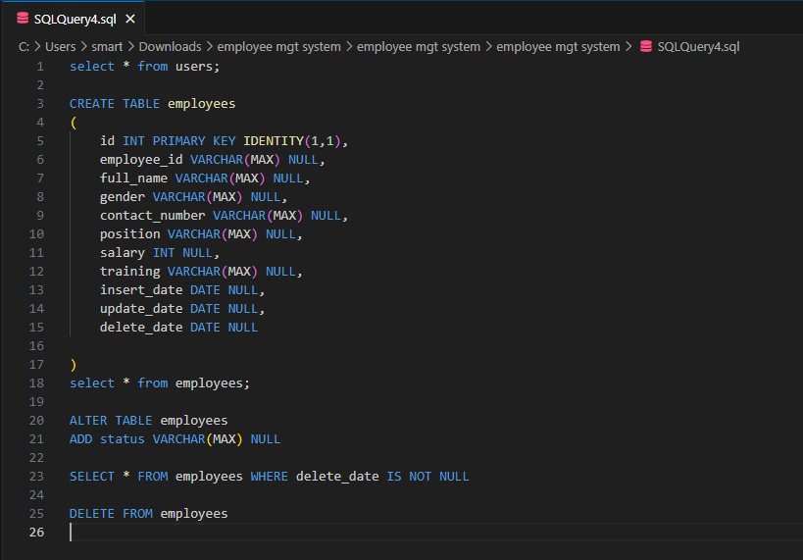

## Register Form

the Sign-up Page functions as the preliminary step in the employee management system, serving as the first point of engagement for new users. Thoughtfully devised and executed, it facilitates the creation of secure user accounts, enabling individuals to register and authenticate themselves, thereby ensuring the system's security and integrity from its inception.

Top of Form

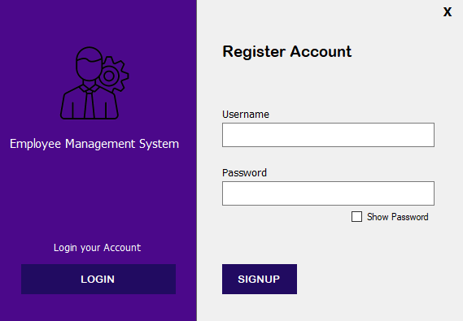

## Log-in Page

Illustrated in the figure below, the Login Page stands as the primary entry point to the employee management system, marking the initial interaction for authorized users. Meticulously crafted and deployed, it enables secure access control and user authentication, ensuring the protection of sensitive data and the preservation of system integrity.

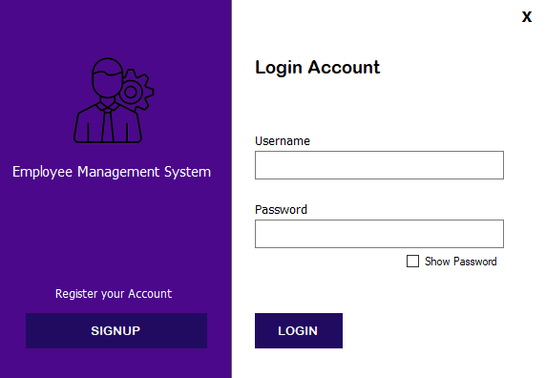

## Main Form

Main Form serves as the central hub of the employee management system, orchestrating seamless navigation and interaction between its various components. This pivotal interface provides users with comprehensive access to essential functionalities, facilitating efficient management of employee data and organizational operations. Designed with precision and foresight, the Main Form embodies the culmination of meticulous planning and programming, offering a user-friendly and intuitive experience tailored to meet the diverse needs of administrators and employees alike.

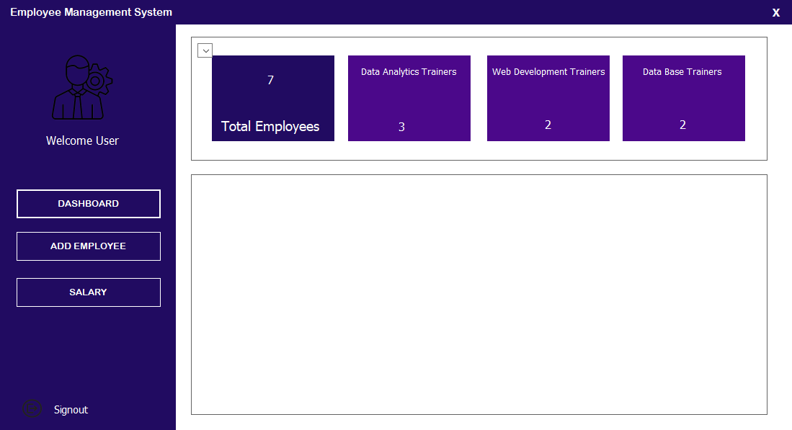

## Dashboard

The Dashboard Form serves as the central hub of the employee management system, comprising five essential panels designed to provide administrators with comprehensive insights into organizational dynamics. Firstly, the panel detailing the total number of employees offers a foundational metric for workforce planning and management. Secondly, granularity is provided through panels enumerating the count of trainers specialized in database, data analytics, and web development technologies, facilitating resource allocation and skill assessment. Lastly, the inclusion of a survey panel enables employees to provide feedback, fostering a culture of continuous improvement. Administrators can access summarized survey results, leveraging employee insights to drive organizational enhancements and promote employee satisfaction. Together, these panels embody the system's commitment to data-driven decision-making and user engagement, ensuring effective workforce management and organizational development.

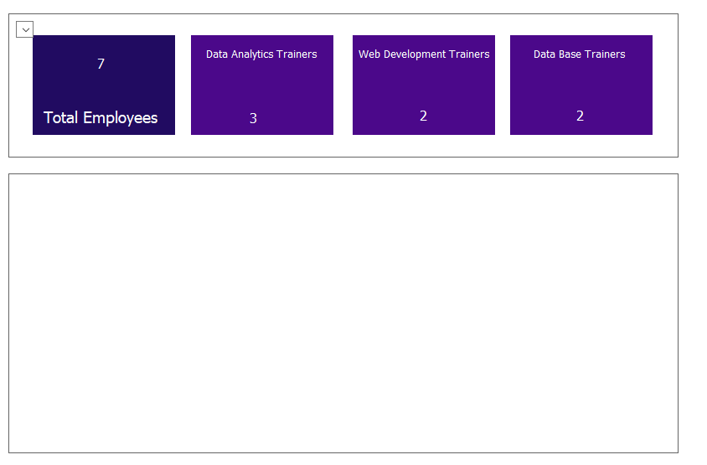

## Add Employees

The Add Employee Form streamlines the process of integrating new personnel into the employee management system through a structured panel of essential questions. Each question, from Employee ID to Phone number, captures key details necessary for effective employee record management. Additionally, a data grid panel offers dynamic functionality, empowering users to seamlessly update, add, or clear the information inputted. This interactive feature enhances user control and flexibility, facilitating efficient data management within the system. Together, these components ensure a user-friendly experience while maintaining the integrity and accuracy of employee records, thereby contributing to streamlined workforce management and organizational efficiency.

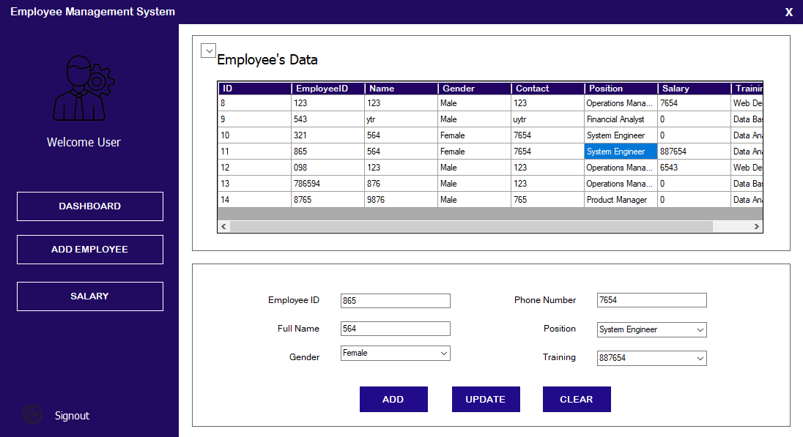

## Employee’s Salary

The Salary Form offers a structured approach to managing employee compensation within the employee management system, comprising two distinct panels. The first panel, featuring essential employee details such as Employee ID, name, position, and current salary, is primarily for reference and remains locked to ensure data integrity. However, the salary field is editable, allowing users to update, add, or clear salary information as needed. The second panel functions as a dynamic data grid, displaying the entered information in real-time, providing users with a comprehensive overview of salary records. This setup facilitates efficient salary management, enabling users to easily update and track employee compensation details while ensuring data accuracy and compliance with organizational policies.

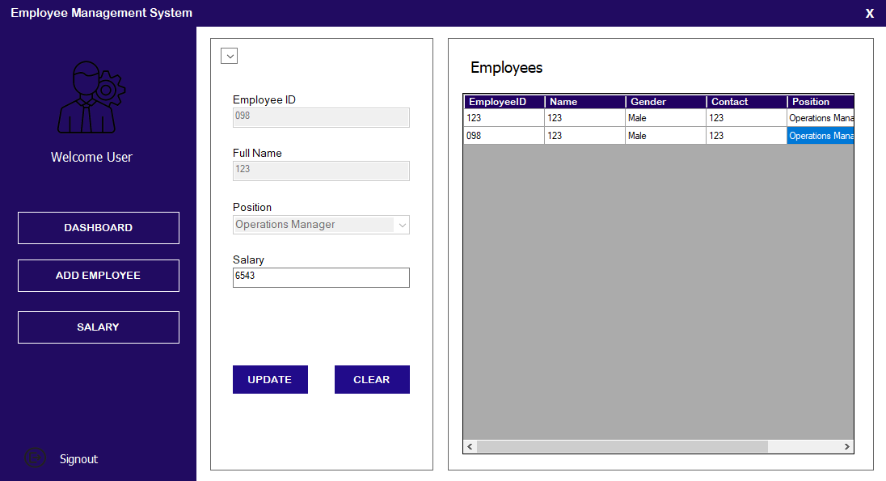

In summary, this chapter shows that Employee Management System comprises several essential forms and functionalities designed to streamline HR operations effectively. The Dashboard Form offers a comprehensive overview, displaying the total number of employees, along with breakdowns of training in database management, data analytics, and web development. It also includes a survey feature to gather employee feedback. Meanwhile, the Add Employee Form facilitates efficient data entry with fields for employee ID, name, position, gender, and training courses. The Salary Form enhances HR management by allowing updates to salary information, displayed alongside employee details in a convenient data grid. Together, these components contribute to a cohesive system tailored to meet the diverse needs of HR management in modern organizations.

# Chapter Six: Conclusion and Recommendations

## Conclusion

This project represents the culmination of extensive efforts to develop and implement a robust employee management system designed to enhance operational efficiency in organizational settings. Our journey towards this goal was characterized by meticulous planning, data-driven decision-making, and collaborative teamwork centered around user needs.

The system's design prioritized simplicity and effectiveness, aiming to streamline employee management tasks and processes. Every aspect of the user interface and underlying architecture was carefully crafted to ensure ease of use and productivity for both administrators and employees.

Central to the system's effectiveness was the utilization of data-driven insights to drive decision-making and optimize organizational processes. By capturing and analyzing key data indicators in real-time, the system facilitated improved workforce management, faster operations, and ultimately, enhanced employee satisfaction and productivity.

The collaborative nature of our approach, which involved close cooperation between developers, administrators, and end-users, was instrumental in shaping a system that not only met technical requirements but also addressed the unique challenges and requirements of real-world organizational environments.

This project underscores the transformative potential of Management Information Systems (MIS) in revolutionizing traditional approaches to employee management. By leveraging technology to enhance workflows and empower employees, we have not only improved operational efficiency but also laid the groundwork for a future where technology plays a pivotal role in optimizing organizational performance.

While this marks the completion of the current project phase, it also serves as a springboard for future enhancements and iterations. Plans for future iterations include the implementation of advanced features such as mobile accessibility, AI-driven decision support, and real-time analytics, further advancing the system's capabilities and its ability to meet evolving organizational needs.

In essence, this project represents more than just the implementation of theoretical concepts; it signifies a step towards progress, showcasing the transformative potential of MIS in reshaping employee management practices. Its impact extends beyond organizational boundaries, contributing to a more efficient and productive work environment, one satisfied employee at a time.

## Limitations of the Study

While this project has achieved its objectives and delivered a robust employee management system, it's crucial to acknowledge and reflect on its limitations:

1. **Resource Constraints**: Certain desired functionalities, such as mobile app integration, advanced reporting tools, or AI-driven features, may not have been implemented in the current version due to resource limitations or time constraints. These additional features could enhance the system's capabilities and user experience but were not feasible within the project scope.
2. **Limited Real-world Testing**: The system may not have undergone comprehensive testing in a fully operational organizational environment. This lack of real-world testing could potentially reveal challenges related to user adoption, integration with existing software systems, and alignment with specific organizational workflows. Real-world testing is essential to validate the system's effectiveness and identify areas for improvement.
3. **Ethical Considerations**: Ethical considerations, such as data privacy and security concerns, may have influenced certain design decisions or testing protocols. While efforts were made to prioritize ethical standards throughout the project, there may be limitations in addressing all ethical considerations comprehensively.
4. **Scalability and Adaptability**: The system's scalability and adaptability to future organizational needs and growth may be limited. As organizational requirements evolve over time, the system may require updates or modifications to remain aligned with changing needs and technological advancements.

Acknowledging these limitations provides valuable insights for future iterations and enhancements of the employee management system. Addressing these challenges can help improve the system's functionality, usability, and overall effectiveness in supporting organizational objectives and employee management processes.

## Recommendations

1. **Feature Expansion**: Implement desired features that were not included in the current version, such as mobile app integration, advanced reporting tools, and AI-driven functionalities, to enhance the system's capabilities and user experience.
2. **Developer Access**: Explore alternative reporting tools compatible with Visual Studio to widen developer access and promote broader adoption among development teams.
3. **Real-World Implementation**: Conduct phased implementation and pilot programs across various organizational settings to gather valuable user feedback for iterative improvement of the employee management system.
4. **Training Programs**: Develop comprehensive training programs and ongoing support mechanisms to facilitate user adoption and mitigate resistance to change among employees transitioning to the new system.
5. **Seamless Integration**: Ensure seamless integration of the employee management system with existing software and hardware utilized in organizational operations to minimize workflow disruptions and optimize system interoperability.
6. **Emerging Technologies**: Investigate the potential integration of emerging technologies such as artificial intelligence and Internet of Things into future iterations of the employee management system to unlock new capabilities and enhance operational efficiency.

Implementing these recommendations will not only address current limitations but also position the employee management system for future scalability, adaptability, and innovation in line with organizational goals and industry advancements.

## References

1. Interpretivism is a research philosophy that focuses on understanding the subjective experiences and meanings individuals attribute to their social world. It emphasizes the importance of exploring the complexities of human behavior and the social context in which it occurs, rather than seeking universal laws or causal relationships. Researchers adopting an interpretivist approach aim to uncover these subjective interpretations and meanings through qualitative methods such as interviews and observations. In fields like sociology and organizational studies, interpretivism is valuable for gaining insight into social phenomena by understanding individuals' perspectives and lived experiences.
2. It's a project management technique where activities are scheduled to be completed within fixed time intervals, helping teams to manage their time effectively and prioritize tasks.